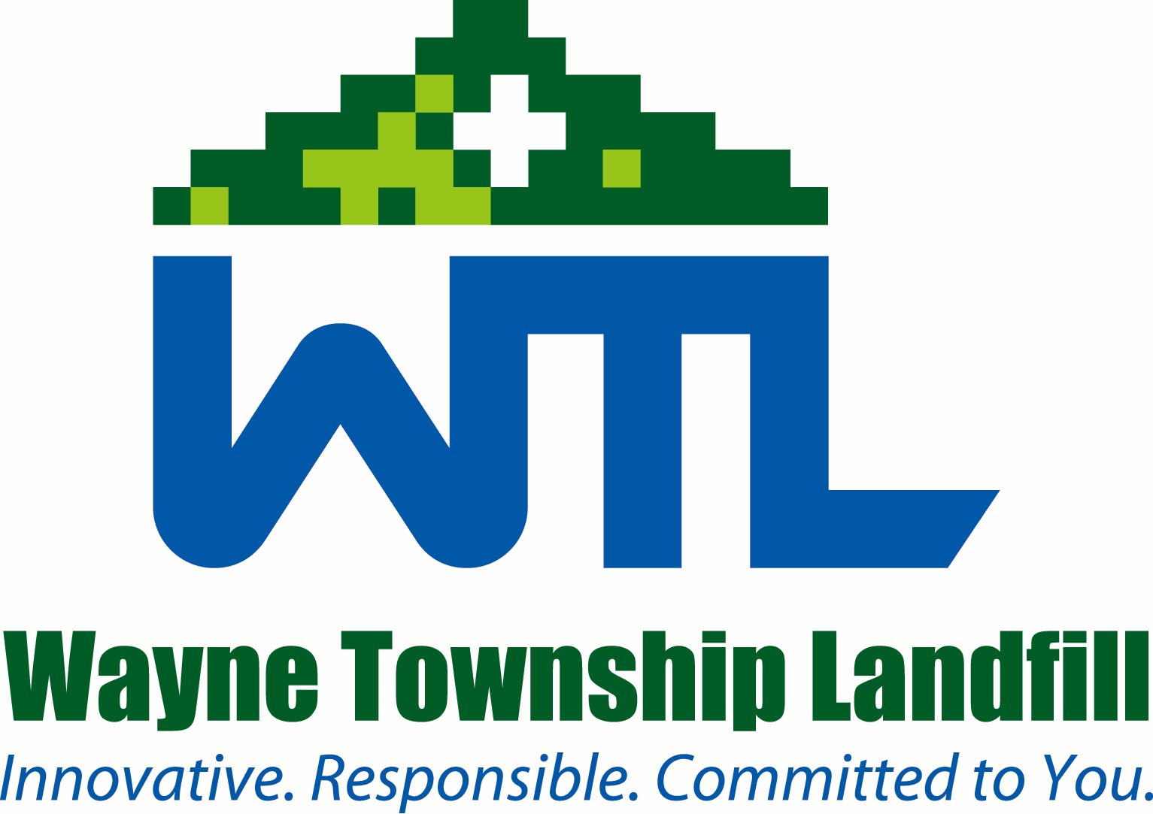
Clinton County
Residential Tire Collection Day

May 9 and 10, 2025

The Clinton County Solid Waste Authority will be holding a Residential Tire Collection Event on Friday, May 9, from 8:00 am to 4:00 pm, and on Saturday, May 10, from 8:00 am to 12:00 pm, at the Authority’s Recycling Center in Wayne Township.

The Following Rules Apply:

- Free to Invited Lycoming County Residents (Brown, Cummings, Limestone, McHenry, Mifflin, Nippenose, Porter, Watson, Jersey Shore Boro, Piatt)

- This collection event is not open to tire dealers, service station operators, repair garages, tire sale outlets or similar facilities. Tires from these facilities will be accepted during our regular business hours for a nominal fee

- 12 car and/or light truck tires will be accepted free of charge (with or without rims)

- Charges will apply to tires from other counties and municipalities as well as for Oversized tires

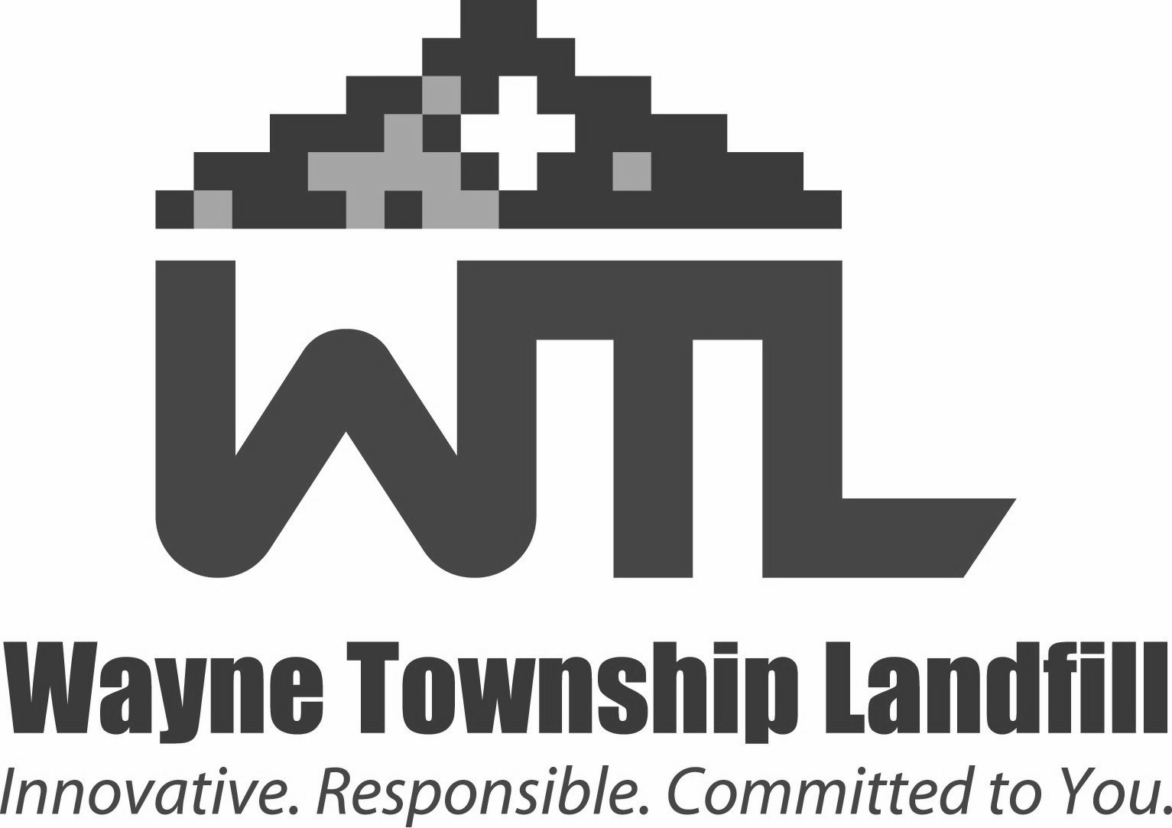
For more information please call us 769-6977 or email us at ccswa@waynetwplandfill.com.
For more information call (570) 769-6977 or email us at ccswa@waynetwplandfill.com.

